**Roots to Fruit Midlands Limited**



**Work Trainee/Volunteer Hand Book**



**Roots to Fruit Midlands Limited**

**Introduction and Contents**

The purpose of this booklet is to provide a clear outline of Roots to Fruit Midlands Limited expectations for attending work place trainees and volunteer placements. The following subjects and policies are addressed within this guide to help you to understand our expectations and to enable you to have a safe and enjoyable time at our centre.

1. **Who are Roots to Fruit Midlands Limited?**
2. **Who are Oakdene Nurseries?**
3. **Staff Structure and Roles**
4. **Health & Safety**
5. **Discipline and Expected Behaviour**
6. **Smoking**
7. **Drugs and Alcohol**
8. **Complaints Policy**
9. **Appeals Procedure**
10. **Data protection**
11. **Environmental Policy**

**1) Who are Roots to Fruit Midlands Limited?**

**Company Formation**

Roots to Fruit is a non profit making company limited by guarantee. Roots to Fruit Midlands Limited was registered with Companies House in March 2013.

**Business Ethic**

Roots to Fruit have 2 main business models; one being a social enterprise the other being a social farm.

**The Social Farm Ethic**

Our intention is to provide alternative education facilities and accredited training for a range of different students with varying unique needs. We will strive to provide horticultural activities to a high standard to people from varying backgrounds with a variety of disabilities in order for them to find purposeful activities that will improve health and well being and economic prospects.

**The Social Enterprise**

The social enterprise part is about trainees and volunteers gaining accredited industry recognised qualifications while working on a real plant nursery producing plants, crops and gardening products these will be sold to produce revenue that can help develop the facilities and prolong the services that Roots to Fruit will be offering to the community. All surplus generated will be invested back into the enterprise.

**2.) Who are Oakdene Nurseries?**

**History**

The site of Oakdene Nurseries has been in the family since 1932 when Oscar Britzeus left Nazi Germany to escape the tyranny of Adolf Hitler. He purchased a plot of mature oak woodland to establish a poultry and pig small holding on the present site. Phil Ensell (son- in -law of Oscar deceased 2007) established a plant nursery just after World War II growing bedding plants and tomatoes in the pre- supermarket days when green grocers, butchers, hardware stores, corner shops, and market stalls thrived and sold plants to the public. Paul Ensell (son of Phil Ensell) came into the business in the early 60’s and is the present owner and manager of the business.Over time the supermarkets pushed out the little shops and stalls and Oakdene Nurseries focused its attention away from wholesale customers and opened its doors to the general public. They still sell to wholesale customers such as gardeners and florists but they now supply mostly to the public and have much wider range of stock from bedding, to vegetable plants, to containerised trees, shrubs and perennials. They still produce their own peat-free compost made from recycled organic waste creating pasteurized loam-based compost mixed and blended to suit a variety of garden uses.

**Relationship to Roots to Fruit Midlands Limited**

Jonathan Ensell (son of Paul Ensell) was the managing director of a landscape gardening company (Oakleaf Landscape Ltd) for 10 years. He has also been lecturing at colleges and offender institutions since 2006. Jonathan Ensell is the director of Roots to Fruit Midlands Ltd. He established this social enterprise along side Oakdene Nurseries to provide services for each other.

***“My intention is that as many people as possible use the facilities, become passionate about horticulture find a great career path and at the same time be a part of planning, developing and maintaining the wonderful facility we have in Oakdene Nurseries”.*** Jonathan Ensell (Director of Roots to Fruit Midlands Limited).

**3.) Companies Staff Structure and Roles**

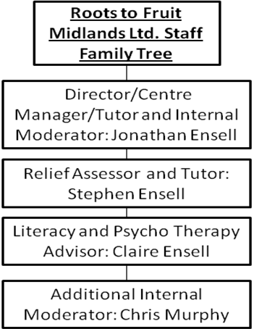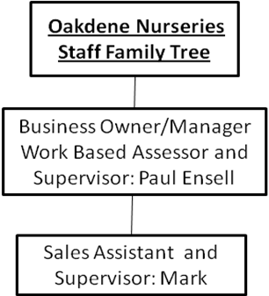

**4) This is the Health & Safety Policy Statement of:**

**Roots to Fruit Midlands Limited**

**General Statement**

We recognise and accept our responsibility to ensure, so far as is reasonably practicable, the health and safety of all our staff, contractors, visitors and those members of the public who may be affected by our activities.

It is our aim to promote, set and maintain the highest standards for health, safety and welfare matters. This will be achieved by:

* providing adequate control of health and safety risks arising from the activities we undertake. Making sure all staff and students have the risks and control measures clearly communicated to them.
* consulting with staff and contractors on matters affecting health and safety;
* providing and maintaining safe premises, machinery and equipment;
* ensuring safe handling and use of substances;
* providing information, instruction and supervision for staff and workplace students;
* ensuring all staff are competent to do their tasks;
* preventing accidents and cases of work-related ill health;
* maintaining safe and healthy working conditions; and
* reviewing and revising this Policy as necessary at regular intervals.

We will endeavour to eliminate any hazards which may result in personal injury, work related illness, fire, property damage or harm to the environment.

Signed: 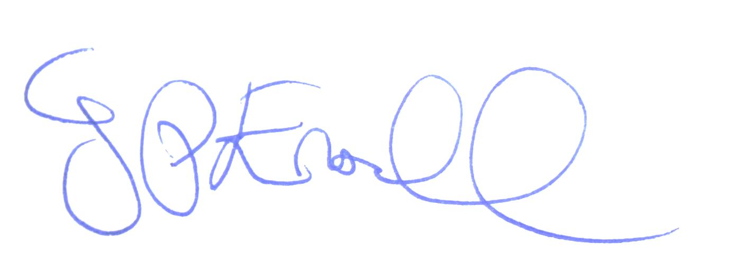

Jonathan Ensell

Date: January 2017

**Organisation and Responsibilities**

The responsibility for health and safety rests with everyone, from the Owners through to each member of staff and work place students. This section sets out the responsibilities under this Policy.

Overall responsibility for health and safety at Roots to Fruit is that of:

Jonathan Ensell

Health and safety advice and support is provided by **NFU Mutual Risk Management Services Limited (RMS)**.

To ensure health and safety standards are maintained and improved, the following individuals are responsible for ensuring that all activities under their control are carried out in accordance with our Health & Safety Policy; and in compliance with statutory provisions:

|  |  |
| --- | --- |
| **Name** | **Area of Responsibility** |
| Jonathan Ensell | Company Director and activity facilitator |

Staff/workplace students have legal duties under the Health & Safety at Work etc. Act 1974. In particular, they must:

* co-operate with management on health and safety matters;
* take reasonable care for their own health and safety and that of others who may be affected by their acts or omissions at work;
* co-operate, so far as is necessary, to enable any duty or requirement imposed on the business by or under any of the relevant statutory provisions, to be performed or complied with;
* not intentionally or recklessly interfere with or misuse anything provided in the interest of health, safety or welfare in pursuance of any of the relevant statutory provisions.

Failure to comply with these requirements may lead to both disciplinary action being taken by the Company and prosecution by the Enforcing Authority.

**Health and Safety Induction**

All workplace trainees must undergo a workplace health and safety induction and training before they can take part with the activities. This induction will be verbally explained and will take on the following format:

* Introduction to the Roots to Fruit Midlands Limited Health and safety policy.
* Roots to Fruit Midlands Limited’s commitment and responsibilities to health and safety.
* Smoking arrangements
* Fire emergencies
* First aid arrangements and general emergencies
* Provision and use of personal protective equipment
* Manual handling
* Risk assessments and safe systems of work regarding specific activity. Power point presentations giving visual images of the hazards and control measures will be given to accommodate those trainees with unique learning needs.
* Following the induction before every new activity the risks will be clearly explained with the control measures in place.
* Equipment/machinery and activities
* Prohibited areas (please see plan of the nursery in relation to this part of the health and safety induction).

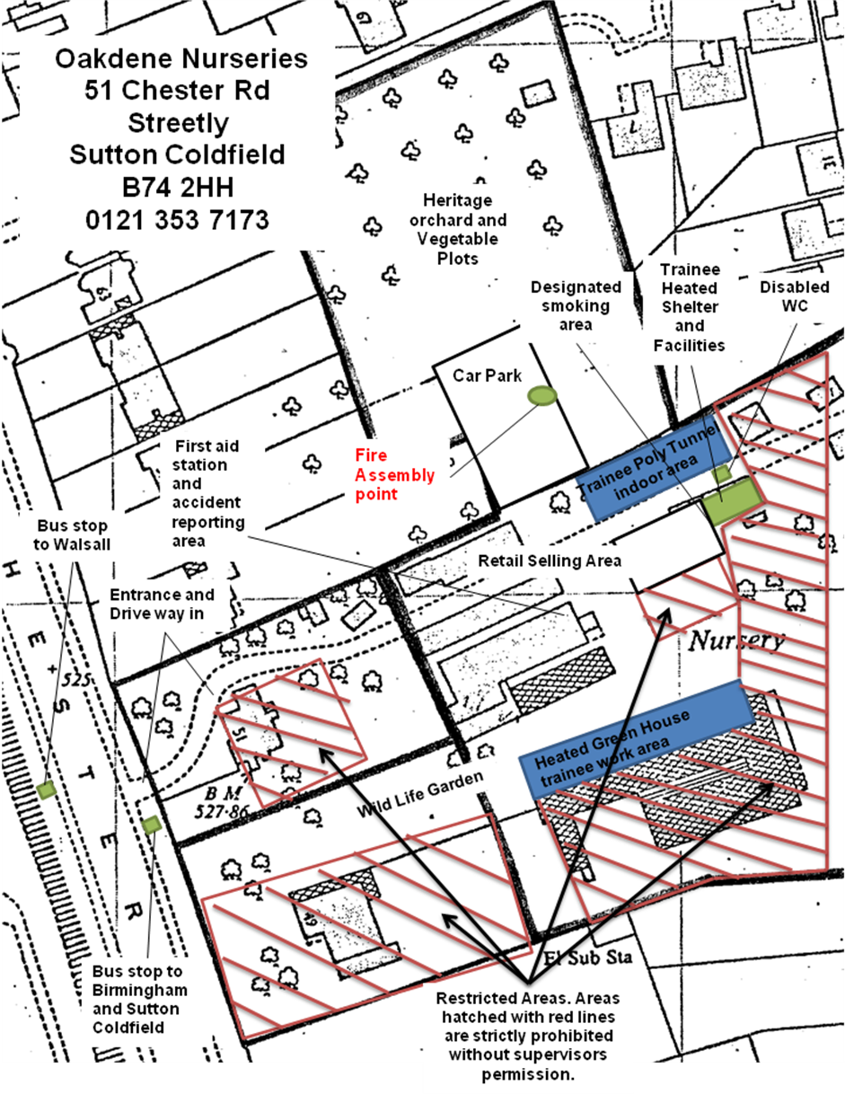

**5) Discipline and Expected Behaviour**

Expected Behaviour

All of the training activities will be carried out on a working nursery NOT A COLLEGE CAMPUS. All trainees need to think of the centre as a work place and they are in a real job situation. The nursery is open to the general public and has a constant stream of customers that it relies on for its revenue. All trainees are to behave and work in a way that presents the nursery to its clients in a favourable light. All work place trainees are expected to:

* Listen to and obey supervisors/tutors
* Always be polite and courteous to staff other trainees and in particular to customers/members of the public
* Follow all health and safety regulations and organisational training and wear the required personal protective equipment
* Engage with all workplace activities completely and to make every attempt to carry out their work to a high standard
* Engage fully with the accredited qualification they are enrolled on by striving to complete all of the work/portfolio assignments to the best of their ability
* To treat tools/equipment/property and stock in the centre with respect and safety
* To turn up to the placement on time and to leave at the agreed time as detailed by the centre.
* To take breaks at designated times and in the correct places
* To wear appropriate clothing i.e to wear clothes suitable for outdoor activities that comply with health safety regulations (safety boots must be worn at all practical sessions) at all activities
* To be dressed in a way that positively reflects the centre and to refrain from wearing clothes that may cause offense (for example wearing t-shirts printed with offensive images/slogans).

**Disciplinary policy Statement**

The organisation works in direct consultation with Oakdene Nurseries and its partner organisations within the assertion of the disciplinary procedure that has been put in place. We hope that this procedure is made clear to you as the trainee and that we strongly advise you to read and understand it carefully and ask and questions as soon as possible so that there are no misunderstandings.

A Traffic light System of Discipline is Adopted where by each trainee knows where they stand on further attendance at the centre based on what has been carried out by the candidate in the past and to point out the consequences of further prohibited actions/poor behaviour. There is a green, amber and red coding systems that will show any trainee where they stand if they have not carried out the expected behaviour or have carried out a prohibited action. Green is the lowest point on the scale and is a verbal warning red is the severest part of the procedure and highlights gross miss conduct and can result in being withdrawn from the centre.

**Summary of Examples of Prohibited Behaviour**

**These the main prohibited forms of behaviour**

Behaviour in The Green Verbal Warning Zone:-

***Absence without a valid reason - Not reporting absence - Lack of motivation / disengaged attitude towards work - Use of offensive language - Continued lateness without a valid reason – Wondering from specified work area – Entering prohibited areas without authorisation - Smoking without permission in non designated areas – Taking unauthorised breaks – Disrupting other trainees from their work.***

Behaviour under Amber written warning/temporary suspension Zone:-

***Unremorseful /continued / multiple repeats of the behaviour/prohibited items mentioned within the green area. A written warning will be provided. Suspension from the centre will be instigated for a prescribed period of time (pending investigation) for:- abusive and offensive language aimed towards staff/other trainees and customers – Taking tools/equipment property / stock away from the premises of Oakdene Nurseries without permission - Entering the site without permission outside the agreed hours of attendance –Using somebody else’s work / forged work to complete a qualification.***

Behaviour under Red **A sign of gross miss conduct and will mean the withdrawal** Zone:-

Continued activities from the previous 2 areas (green and amber) with no change in attitude and a complete disregard for the training centres agreed prohibited and expected behaviour. Withdrawal is on a first strike basis if the trainee is involved in or caries out any of the following prohibited activities:- ***Stealing (with intent to sell or keep) any tools/equipment property / stock away from the premises of Oakdene Nurseries – Selling/dealing/taking of drugs/alcohol/ illegal items on the nursery premises – Physical abuse towards staff/other trainees and customers – Bullying of any kind towards staff/other trainees and customers - Deliberate and reckless abuse/vandalism of tools/equipment/property and stock.***

Every trainee within their induction will see the disciplinary procedure within the centre induction and will sign to say that they understand and agree with the policy.

Please see Roots to Fruit Midlands Limited Disciplinary and Trainee Withdrawal Procedure for more detail.

*“It is our hope that you join the work training placement and enjoy the activities provided, that you find satisfaction from the projects you are involved with and that you are able to develop both professionally and personally form the experience and our hope with this that we never have to evoke any of these disciplinary areas on any workplace trainees.”* **Jonathan Ensell (Roots to Fruit Midlands Limited)**

**Withdrawal Procedure**

It is not just a disciplinary issue that can involve the process of withdrawing a student from the training centre. A trainee may have circumstances that mean that they can no longer attend the centre for a variety of legitimate reasons. As a centre we will try to be as supportive as possible to any trainee that has to leave prematurely through discussions and outlining their options so that they can progress further both professionally and personally without hindrance. The training centre will take a particular interest in setting in motion a prescribed withdrawal strategy for those leaving an accredited qualification prematurely.

If a trainee is not engaged with the process through voluntary absence without a legitimate excuse the centre will make every effort to reclaim as much of a qualification as possible in the absence of the candidate and send any relevant certificates of achievement to the address provided.

If a candidate for what ever reason stops attending for more than 3 months a re-evaluation of the original training agreement will be made and a decision will need to be made as to whether funding will still be in place for further attendance.

Please see Roots to Fruit Midlands Limited Disciplinary and Trainee Withdrawal Procedure for more detail.

**6.)Smoking**

Smoking is prohibited during work activities and will only be allowed during allotted breaks within designated areas (please see the plan of the nursery).

**7.)Drugs and Alcohol**

If a workplace student is found to be under the influence of drugs/alcohol at work, there could be serious safety, work and personal consequences. Ifa workplace student is known to be, or strongly suspected of being, intoxicated by drugs during working hours, arrangements will be made for the employee to be sent home for the rest of the day.

No drugs must be brought onto or consumed on Roots to Fruit Midlands Ltd. Premises at any time.

Any breach of these rules will result in disciplinary action being taken which is likely to result in being suspended or barred from training programmes.

Itis Roots to Fruit's intention to deal constructively and sympathetically with a workplace student drug-related problems, such as drug dependency. When it is known that a workplace student has a drug problem, Jon or Claire Ensell will be able to provide advice and guidance on how to seek assessment of the problem and, if necessary, suitable treatment. The primary objective of any discussions of this type will be to assist the workplace student with the problem in as compassionate and constructive a way as possible.

Whilst certain personnel records will be necessary, any discussions of the nature of a workplace students drug problems and the records of any treatment will be strictly confidential unless the workplace student agrees otherwise.

**8.) Complaints Policy Statement**

**Roots to Fruit Midlands Limited** is committed to providing excellent customer service to everyone who is affected by its operation. We do not look at complaints as unwanted, and we are firmly committed to a process of continuous improvement of which the complaints procedure is just one element.

The objectives of this complaints procedure are to ensure that:

* any complaints that are received are investigated at the appropriate level in the organisation,
* all complaints are actioned in the most expeditious way,
* persons making complaints know how their complaint will be dealt with, and
* wherever possible, lessons are learned.

***“As work place trainees you will be receiving an alternative education experience, not only do we value you for your input through work experience but also as a volunteer.”* Jonathan Ensell (Director Roots to Fruit Midlands Limited).**

When making formal complaints customers are asked to write or email an explanation of the issue that has caused them to be dissatisfied. A complaint should also contain an explanation of what the person making the complaint requires to be done to resolve the issue. Complaints should be sent to the Tutor/Work Supervisor in order to register them within the procedure. The Tutor/Work Supervisor will send an acknowledgement by return, giving a complaint registration number. Including this number with any further correspondence will assist **Roots to Fruit Midlands Limited**.

The Tutor/Work Supervisor will refer each complaint to an appropriate Manager for the

first review, unless such a person is specifically mentioned in the complaint, in which case it will be referred to a Director/Trustee of the organisation.

All correspondence about complaints will be treated as confidential. When the first reviewer has considered the detail of the complaint, the person raising the complaint will receive a written response detailing any proposed remedial action. This will be done within 28 days of

the receipt of the original complaint. If this is not possible, the Tutor/Work Supervisor will explain this in writing within the 28 days.

The person raising the complaint will also be told in this response that they can request a second review. If a second review is requested, the matter will be referred to a more senior person within Tutor/Work Supervisor. This may be the Chair of the Board, a Trustee or the Chief Executive as appropriate. Following the second review, the person raising the complaint will be provided with a written response detailing any changes to the previously proposed remedial action. In the majority of cases the second review will be the final position of **Roots to Fruit midlands Limited**.

**Roots to Fruit Midland's Limited Qualification Appeals Procedure**

If learners wish to enquire or appeal against internal or external assessment decisions, they can follow the guidelines below:

**9.)The Data Protection Policy Statement and Principles**

There are eight data protection principles that are central to the Act. Roots to Fruit Midlands Limited and all work place students must comply with these principles at all times in their information-handling practices. In brief, the principles say that personal data must be:

1. Processed fairly and lawfully and sensitive personal data may only be processed

with the explicit consent of the employee

1. Obtained only for one or more specified and lawful purposes
2. Adequate, relevant and not excessive in relation to the purposes for which it is processed.
3. Accurate and, where necessary, kept up-to-date.
4. Not kept for longer than is necessary.
5. Processed in accordance with the rights of employees under the Act.
6. Secure.
7. Not transferred to a country or territory outside the UK

**Workplace Students consent to personal information being held**

Roots to Fruit holds personal data about its employees and, by signing this induction agreement, you have consented to that data about you being processed by Roots to Fruit. Agreement to Roots to Fruit processing your personal data is a conditionof your training.

Roots to Fruit also holds limited sensitive personal data about its work place students and, by signing this agreement, you give your explicit consent to our holding and processing that data, for example sickness absence records, particular health needs and equal opportunities monitoring data.

**10.) Environmental Policy Statement**

Roots to fruit recognises that its operations have an effect on the local, regional and

global environment. Our whole approach is to bring about change in society, in communities, in groups and in individuals and this should include positive change around any impact we have on environmental issues. As a consequence, Roots to Fruit is committed to continuous improvements in environmental performance and the prevention of pollution. Environmental regulations, laws and codes of practice will be regarded as setting the minimum standards of environmental performance.

**Objectives**

At Roots to Fruit we will: Use nature (natural) resources prudently and minimise the generation of wastes. Contribute to the protection and improvement of the built, historic and natural environment. Enable the community to increase their awareness and understanding of environmental issues, and to acquire skills for environmentally responsible behaviour and action. Monitor, evaluate and constantly seek ways of improving our environmental performance.

Oakdene nurseries was born out of a time when recourses were extremely limited after the rationing days of world war 2. They were innovative in carrying on with their business in order to keep producing high quality plants and vegetables. Those principles still remain as a strong ethic for Roots to Fruit today. We will save money and natural resources and reduce landfill by:

* Making and using peat free loam based composts from recycled organic waste
* Washing and re-using pots and plastic cellular containers for new crops
* Manufacture on site as many wooden seed trays from discarded pallets as possible and reduce the need to purchase plastic trays
* Sell minimum of 90% of the stock grown on the site and sold from the site to reduce our carbon foot print
* Use as few chemicals (such as pesticides) as possible through good industry practice
* 90% of the teaching resources will be either used to enhance the site or sell to produce surplus that can be re-invested into the social enterprise.